Created by Lionel Weber, the 31 July 2012
Modified by Lionel Weber, the 19 December 2012

How to create/update a CK editor template (email template, or memo template…)

Introduction
The integrated html editor used in the wigii system is CKEditor. This editor can manage html templates. The format to define those html templates is done in a .js file.

Update steps
- Open the system, go in the related namespace, and open an item or select a few item and click on email to open the Emailing activity
- Select the template you want to update with the template button 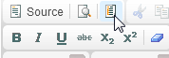
- Update the text as you want
- Click on Source to get the html. Copy paste it in a notepad
- Remove all lines to make the html all on one line (you can use search and replace for that with the regex pattern \r\n replaced by nothing)
- Lookup in the www/client folder. There is at least a CKTemplate.js file and could have other namespace_CKTemplate.js.
The CKTemplate.js is the file containing the templates common to the whole system.
The namespace_CKTemplate.js contains template only for the specific namespcae.
In a namespace_CKTempalte.js file don’t forget to change the name of the templates from “default” to the namespace name as:
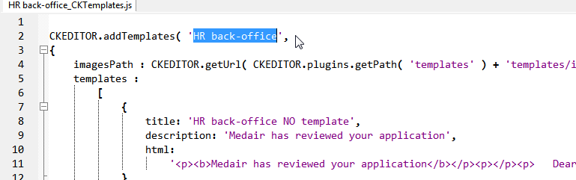
- When you find out the correct CKTemplate file containing the template you want to update, replace the html content with the new html content (all on one line).
- To check if the changes occurs properly you need to remove all the cache of your browser
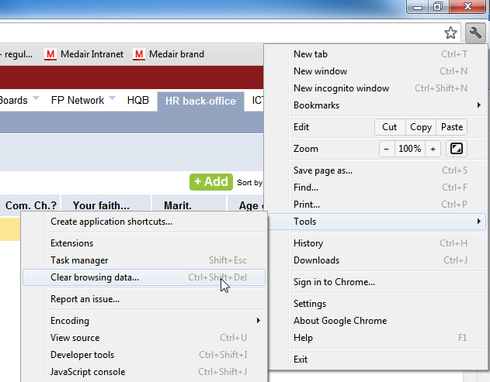
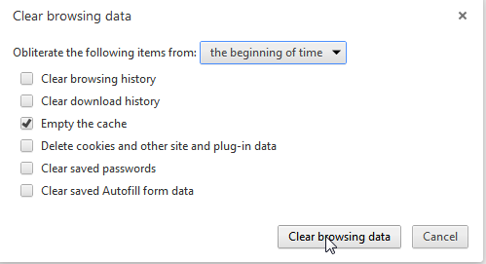
then close the browser and reopen it. You should see your changes.

How to define a template in a Blobs field
You can prefill any Blobs field having htmlArea=”1” with a template content. To do that you just need to add an attribute template=”…” with the template name. This template name must be defined in the global CKTemplate.js file. Using namespace templates is not working for this feature.

